**Pandas**

* Pandas is a python library.
* Pandas is used to analyze data analysis.
* Pandas is used for working with data sets.
* It has functions for analyzing, cleaning, exploring, and manipulating data.
* The name "Pandas" has a reference to both "Panel Data", and "Python Data Analysis" and was created by Wes McKinney in 2008.

Why Use Pandas?

* Pandas allows us to analyze big data and make conclusions based on statistical theories.
* Pandas can clean messy data sets, and make them readable and relevant.
* Relevant data is very important in data science.

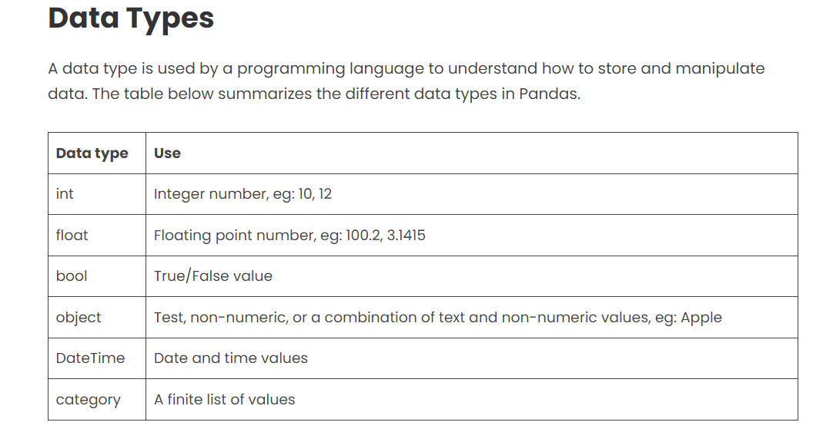

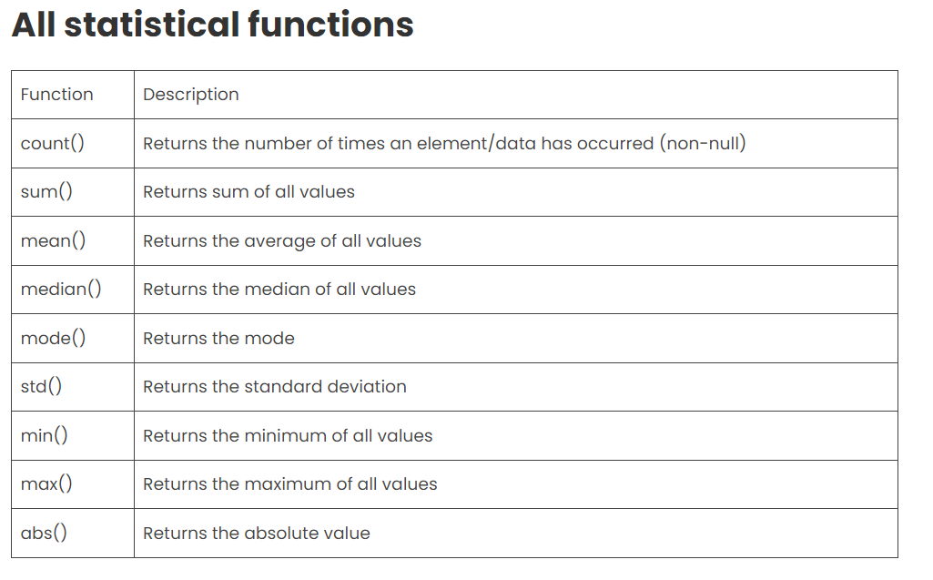

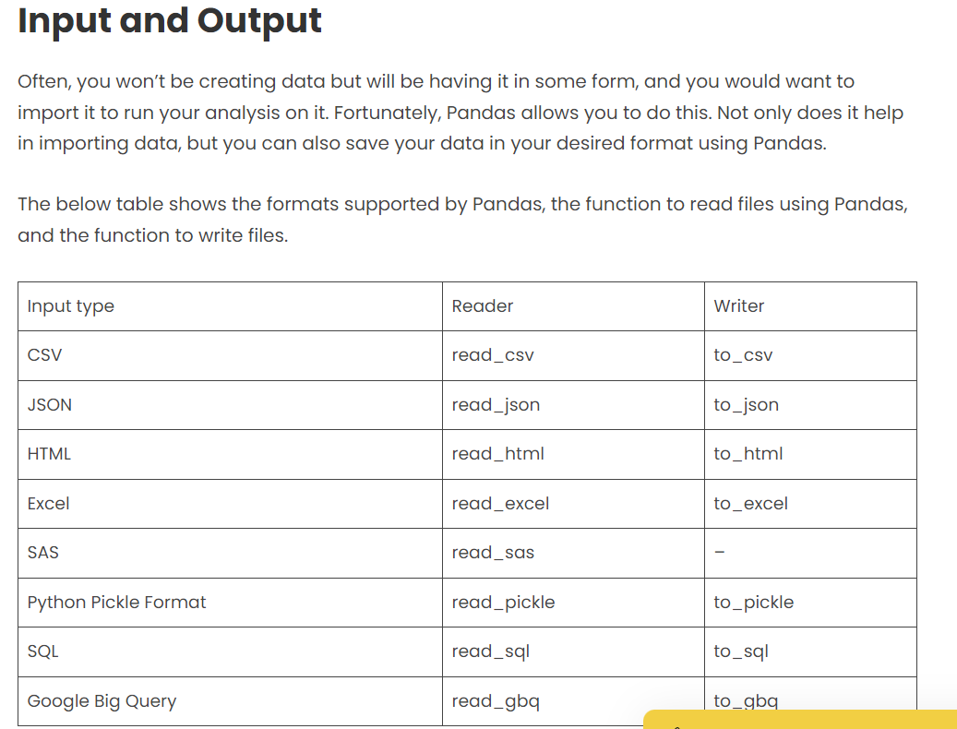

It supports two data structures:

* [Series](https://www.geeksforgeeks.org/python-pandas-series/)
* [Dataframe](https://www.geeksforgeeks.org/python-pandas-dataframe/)

## What is a Series?

A Pandas Series is like a column in a table.

It is a one-dimensional array holding data of any type.

## DataFrames

Data sets in Pandas are usually multi-dimensional tables, called DataFrames.

Series is like a column, a DataFrame is the whole table.

### **Features of DataFrame**

* Potentially columns are of different types
* Size – Mutable
* Labeled axes (rows and columns)
* Can Perform Arithmetic operations on rows and columns

Create DataFrame

A pandas DataFrame can be created using various inputs like −

* Lists
* dict
* Series
* Numpy ndarrays
* Another DataFrame

##Pandas use the loc attribute to return one or more specified row(s)